PROJECT TITEL : Creating Blog Using Wordpress Platform

TEAM MEMBERS : 1. PAWAN KUMAR RAJAK (512720105007)

2. DINESH M (512720105002)

3. BABU R (512720105305)

4. MUKESH V (512720105322)

BLOG NAME : DIGITAL INDIA

CATEGORY: DIGITAL MARKETING

Email: [pk540254@gmail.com](mailto:pk540254@gmail.com)

Wordpress Blog URL: <https://digitalmobileservice8.wordpress.com/2023/10/17/digital-india-2/>

***STEPS TO CREAT A BLOG USING WORDPRESS***

**Step1 : Search “ Wordpress Blog”**

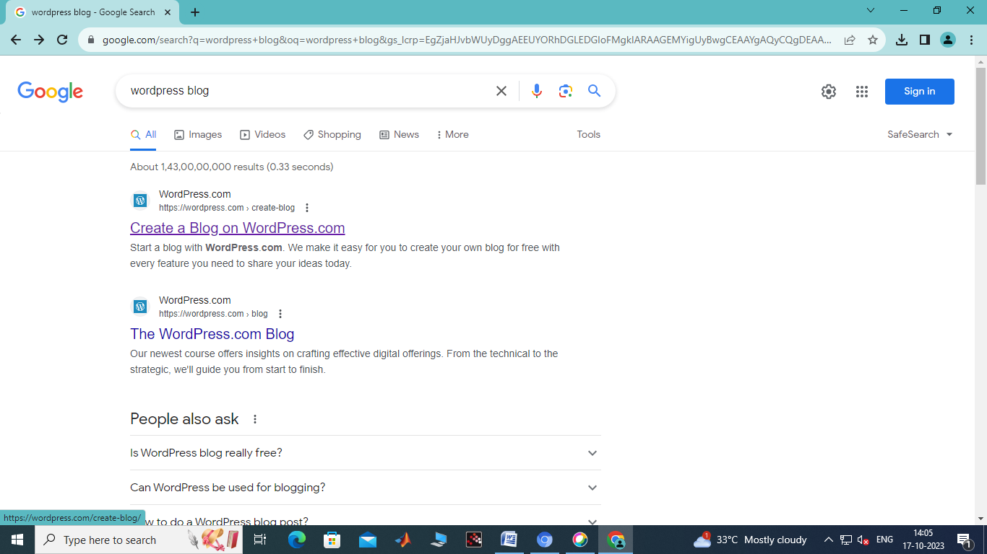

**Step 2: Click “Get Started”**

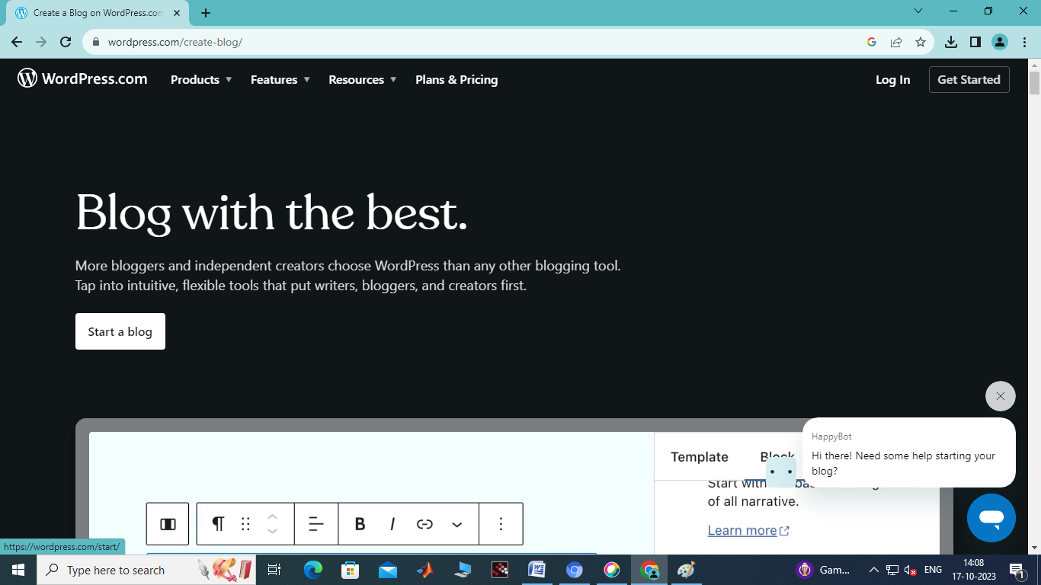

**Step 3: Sign Up With Email or Google**

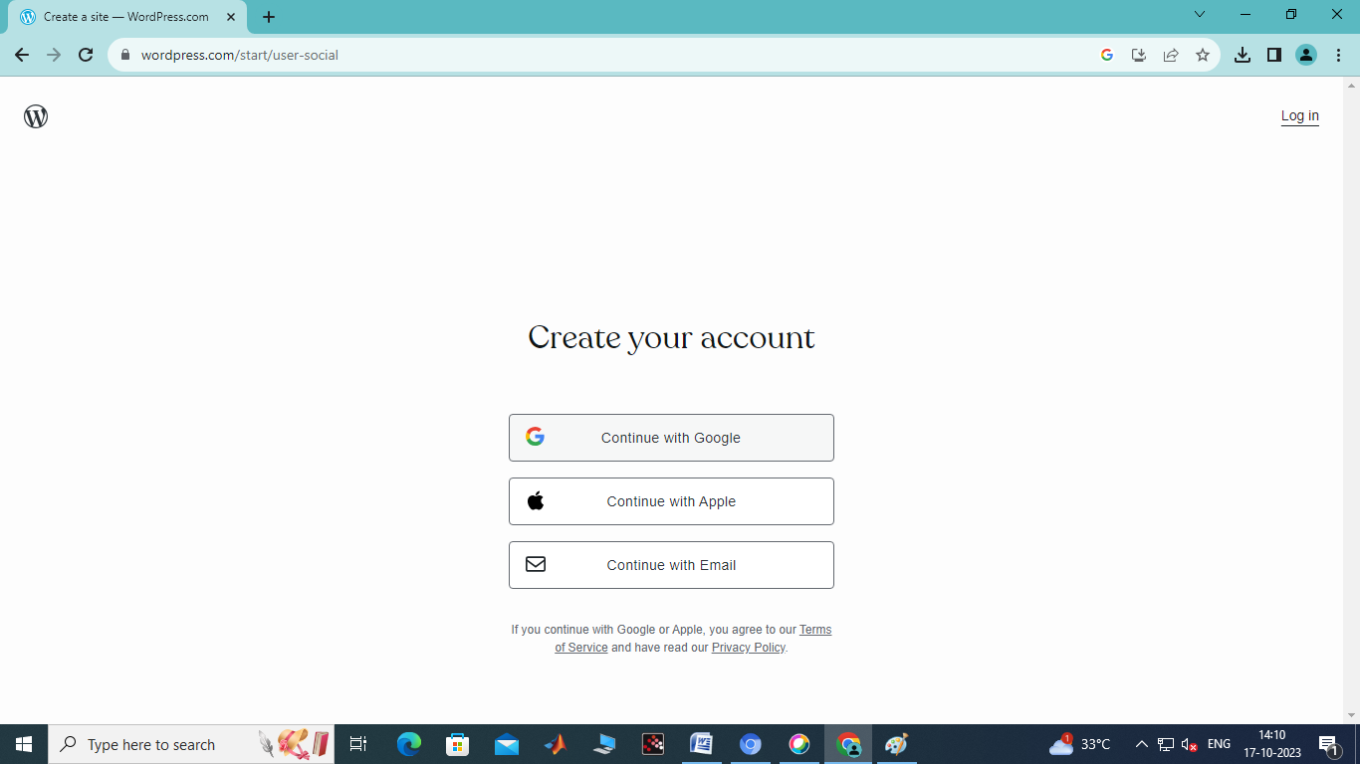

1. **Step 4: Choose a domain name and hosting**
2. 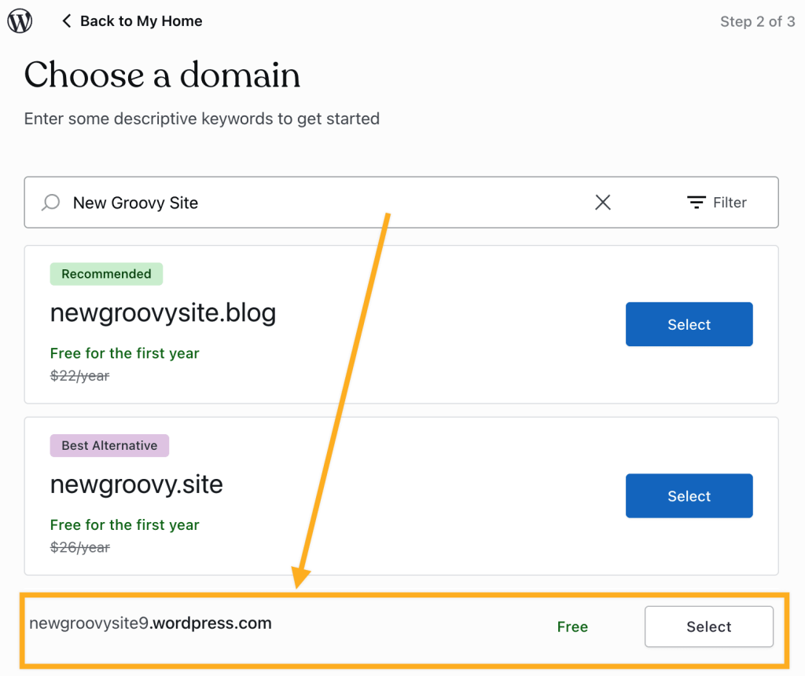
3. **Step5: Install WordPress.**
4. 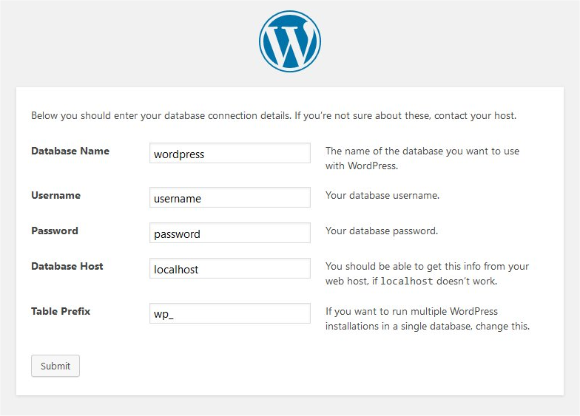
5. **Step 6: Select a theme.**

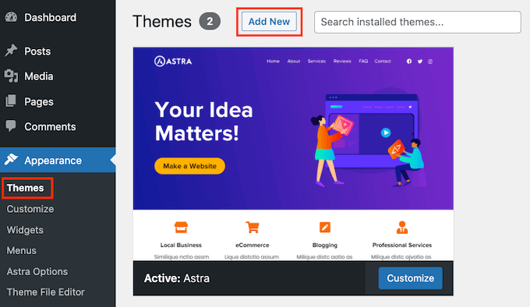

**Step 7: Add the “New Post” to your WordPress blog**.

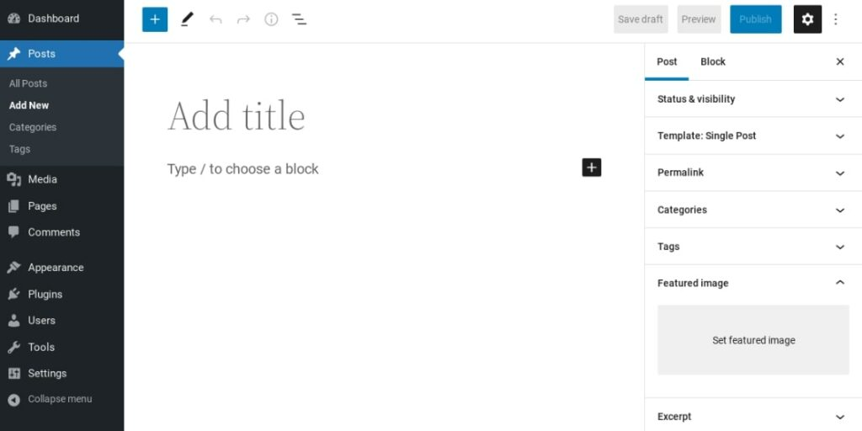

**Step8: Publish your blog**.

